**Feeback 21 – 17/02/2025**

**PROFILE**

**Checks and Clearances**

**Australian Citizen:**

Upload Evidence

The choose file is set on default image file, it should be set for all files

**Choose file:** We cannot delete the file once added, please use same design than before:

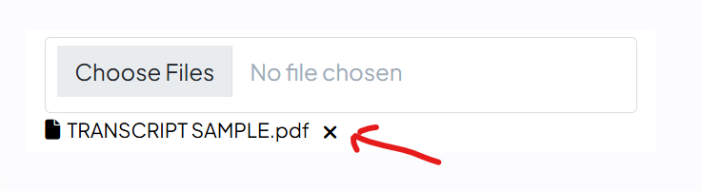

**Permanent Resident:**

**Visa Subclass:** Can we add a search to find the subclass easier when we type the number: example: if I type 101, then subclass 101: child visa should come straight.

Upload Evidence

The choose file is set on default image file, it should be set for all files

**Choose file:** We cannot add any file, please add the possibility to delete the file once added, please use same design than before.

**Submit:** doesn’t work as we cannot add file.

**Visa Holder:**

Upload Evidence

The choose file is set on default image file, it should be set for all files

**Choose file:** We cannot delete the file once added, please use same design than before:



**NDIS Worker Screening Check**

Upload Evidence

**Choose file:** We cannot delete the file once added, please use same design than before:



**Working With Children Check (****WWCC):**

**The fields are missing:**

**Please place the fields like this:**

State

If New South Wales (NSW) selected:

WWCC Clearance Number:

If Victoria (VIC) selected:

WWCC Card Number:

If Queensland (QLD)selected:

Blue Card Number:

If Western Australia (WA)selected:

WWCC Card Number:

If South Australia (SA)selected:

WWCC Certificate Number

If Tasmania (TAS)selected:

Registration to Work With Vulnerable People (RWVP) Card Number

If Australian Capital Territory (ACT) selected:

Working With Vulnerable People (WWVP) Registration Card Number:

If Northern Territory (NT)selected:

Ochre Card Number:

Expiry Date*

Upload Evidence

Choose file

+ add another **WWCC** (with always the possibility to delete the added one)

Sate

Expiry Date

Upload Evidence

Choose file

**Police Clearance:**

The choose file is set on default image file, it should be set for all files

**Choose file:** We cannot delete the file once added, please use same design than before:



**Submit: please use same with the possibility to delete the added file. Please remove below:**

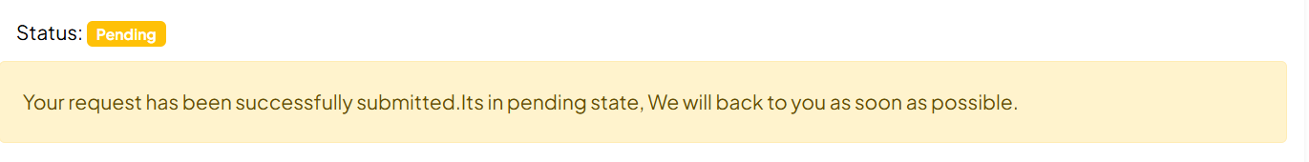

**Specialized Clearances:**

**The fields are missing:**

Sate

Specialized Clearance type: (text field)

Specialized Clearance Number:

Expiry Date

Upload Evidence

Choose file

+ add another Specialized Clearance (with always the possibility to delete the added one)

**Professional Memberships & Awards:**

**I can’t acces:**

